**An include structure has to be pre-existing.**

Go to SE11. Create structure. The structure can be used in multiple tables.

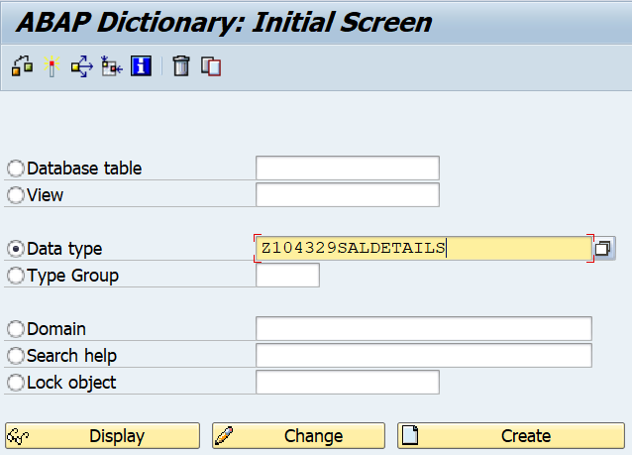

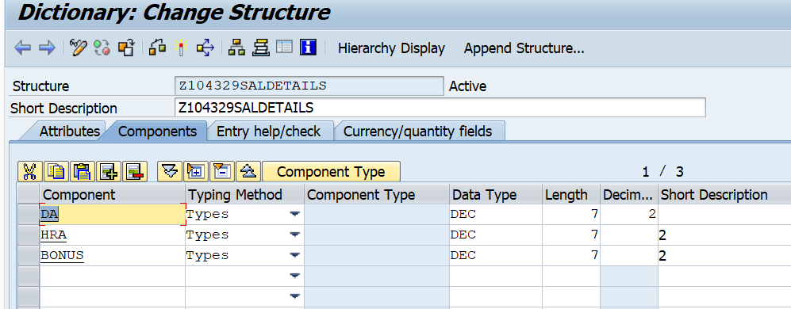

Go to the ZXXXXXXEMP table created by you.

